COME JOIN OUR TEAM !
Bring A Great Value To Your Clients, While Getting Paid A Generous Monthly Residual Commission! True WIN-WIN For Everyone!
Make a $1000 or more WITH EACH SALE of our highly demanded and easy to sell Reputation Marketing Packages.
- Services that are needed by ANY BUSINESS OF ANY SIZE – the Hottest Trend This Year!
- Realistic 6-Figure a year potential; get paid on a monthly HANDS-FREE RECURRING basis!
- Your earnings are uncapped – make as much as you like!
- All commissions are paid immediately!
- Exclusive Territories in the U.S., and ability to sell ANYWHERE IN THE WORLD!
- Additional incentives – Paid Referral Program, and more…
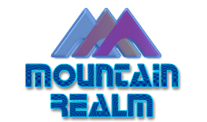
Visit http://mountainrealmcareers.com to learn more today!

